Team id: PNT2022TMID30625

Project Design Phase-II

Data flow diagrams and user stories

|  |  |
| --- | --- |
| Team ID | PNT2022TMID30625 |
| Project Name | Project- Signs with Smart Connectivity for Better Road Safety |
| Maximum marks | 4 marks |

**Data Flow Diagram:**

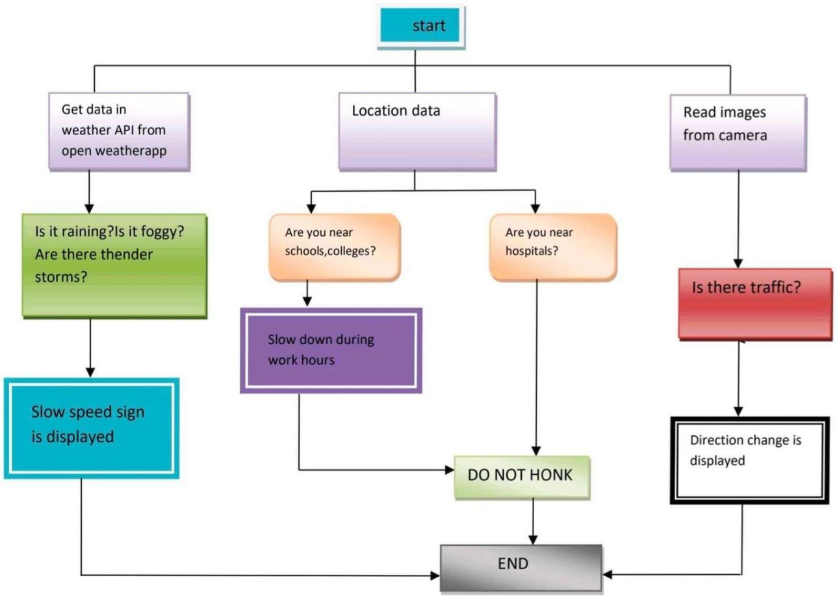

SENSOR

SENSES

WARNING SIGNS ARE SHOWN THROUGH SENSORS AND WEB APPLICATION

VEHICLES ARRIVES

Warning signs or sound is shown through sensors

VEHICLES ARRIVES

**User Stories:**

